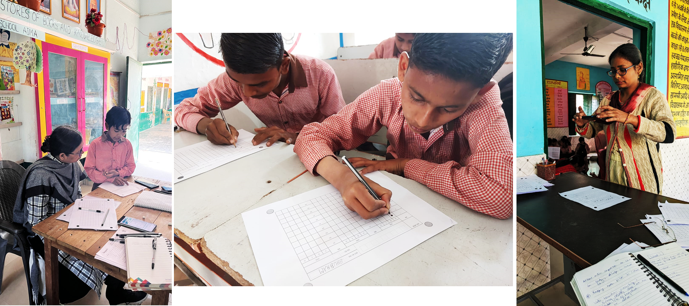

How Saral App transformed the course of assessments in

Uttar Pradesh

**How did it all start?**

The education system in India has undergone significant changes in recent years, and Uttar Pradesh has emerged as a state that is leading the way in educational reform through technology and innovation. However, implementing effective state initiatives to improve educational outcomes in Uttar Pradesh can be a complex process, given the state's vast size. Over 47 million students are studying in schools, with the Basic Education department of Uttar Pradesh alone accounting for around 19 million students, 650,000 teachers, and 170,000 government schools spread across 75 districts. To achieve success in resolving these complexities and implementing initiatives at scale, it is essential to have a grassroots-level understanding of the needs and challenges faced by students and teachers.

One such initiative that has significantly contributed to gaining this understanding around student learning and transforming data capture is the implementation of OMR (Optical Mark Recognition) based NIPUN Assessment Test for government school students in Uttar Pradesh, India. In September 2023 around 17 million students in grades 1to 8 were assessed successfully using Saral App in a phygitized manner.

**Challenges Uttar Pradesh was facing in gaining grassroot level understanding of student’s learning levels**

The state had a strong desire to gain a deeper understanding of student performance in order to effectively cater to various programs and student learning needs, such as NIPUN Lakshaya, which aimed to achieve universal foundational literacy and numeracy in primary schools by 2025.

However, traditional assessment methods, such as DIET Led Assessments and Quad Assessments, persist several challenges. These methods were not at scale or student level, making it difficult to obtain reliable data for the state to make informed decisions. Additionally, the time it took for data to reach the central department from traditional assessment methods was too long, as the process involved physical question paper preparation, exam conduction, answer sheet evaluation, result generation and then manually digitizing results, leading to a delay of up to three to four months.

**Let’s understand the implication of the process being followed on the teachers**

*Meet Suresh Ji, a primary school teacher in Bharatpur Village, Cholapur Block, Varanasi. Suresh Ji, like many teachers, has the noble task of nurturing young minds. To track his students' progress, he conducts assessments every three months - a process involving question paper preparation, exam conduction, answer sheet evaluation, and result generation.*

*The State administration also wants visibility on the performance of students across the state. To enable that, Suresh ji needs to share the student results with his superiors, from where the data gets digitized manually and reaches the State Administration.* ***The process is lengthy, repetitive and takes away Suresh ji’s precious teaching time.***

**NIPUN Assessment Test using Saral App**

To address challenges State was facing, a quick and efficient method of collecting student-level data in a digitized format was deemed essential. This led to the development of the Saral App, which provided a more frequent and comprehensive method of assessing student performance at scale. The idea was to cover the entire state, rather than being sample-based, and collect student level learning data, that could be quickly analyzed and used to create targeted interventions.

The solution replaces the old answer sheets with OMR-based answer sheets and allows teachers to scan the answer sheet through the Saral App. This process instantly digitizes data and allows the state to receive digitized data on the very same day of scanning. The Saral App is AI-powered, which makes data collection faster and easier, and allows for multiple iterations of assessments in a year in an easy manner.

The implementation of Saral Assessments requires a one-time investment of effort towards planning, operations, and support from various stakeholders across the hierarchy which is similar if any other assessment is to be conducted at scale.

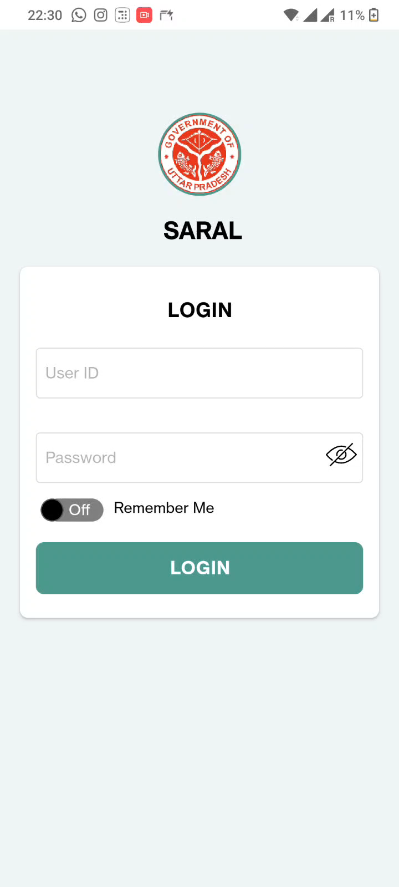

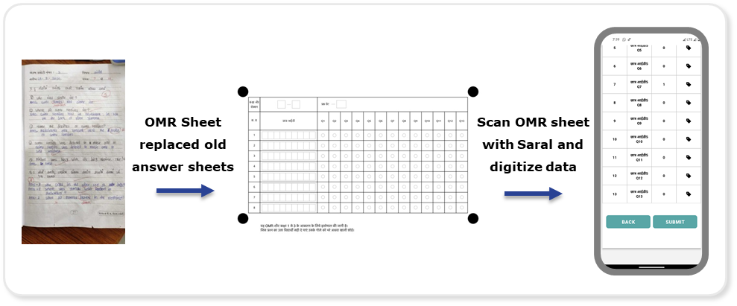

**How Saral App eases out the process for teachers, let’s continue with Suresh ji**

*Now with the Saral App, there is no requirement for Suresh ji to create question papers or assess answer sheets. Suresh ji will receive packaged question paper and OMR sheets for conducting assessments. On the assessment day, students will mark their responses on OMR sheets, and Suresh Ji will scan the answer sheets using the SARAL App. Within seconds, the responses will be digitized and data will be shared with the State. The process which was taking weeks of Suresh ji’ time was cut to 1 day responsibility of conducting the assessments and submit the answer sheets using Saral App.*

*Suresh ji will also be able to get back results quickly after results will be evaluated automatically in backend and communicated to ground through* [NIPUN Bharat Monitoring Centre](https://drive.google.com/file/d/1HuRqNKnUrY-gbxXRGnhHheATY-QFUDrR/view?usp=drive_link) (NBMC) *Dashboards.*

**How Uttar Pradesh Implemented Saral Based Assessments?**

**Let's uncover this transformation Story**

**The first-time assessments were conducted at scale using Saral App**

In December 2022 around 14 million students in grades 1 to 8 were assessed against 47 learning outcomes across 3 subjects (Hindi, Maths and Science) using a phygitized approach for the first time in the country using Saral App. Centralized model question papers were prepared by SCERT as a benchmark for other districts to prepare Question papers in a decentralized manner. Teachers, ARPs and other ground staff were trained through YouTube Live sessions and regular communications including videos, Instructions etc. State’s [NIPUN Bharat Monitoring Centre](https://drive.google.com/file/d/1HuRqNKnUrY-gbxXRGnhHheATY-QFUDrR/view?usp=drive_link) (NBMC) was enabled as an Issue resolution center to resolve issues coming from the ground.

Although steps were taken by the team for the successful conduction of the exam at scale, multiple challenges were faced during and after SARAL assessments. The most significant hurdle encountered was the substantial data loss and the low reliability of captured data. This, coupled with the sheer volume of decentralized question papers, resulted in the inability to evaluate results on the backend, ultimately preventing the realization of anticipated outcomes in this round of assessments.

However, multiple challenges were faced, State and other involved implementation partners were determined to make it a success. Whole process was reviewed and problem nodes were identified through first principal problem solving. Hypotheses driven Issue diagnosis plan and SARAL App user testing plan was created to validate all the identified problem nodes. Based on the extensive root cause analysis, many other challenges came to light.

**Operational Challenges:**

1. Decentralized Question Paper Setting: The creation of ~600 sets of question papers across districts, each with different Learning Outcome (LO) mappings led to significant delays in codifying answer keys for different districts in backend for result generation and thus delay in result evaluation.
2. Decentralized Printing of OMR Sheets: The decentralized printing of OMR sheets resulted in a wide variety of sheet types used for assessments, causing scanning difficulties during the assessments.
3. One-Day Assessments for all grades: The lack of adequate number of teachers in schools made it exceptionally challenging to conduct exams for class 1-3 and 4-8 in a single day.
4. Training and Exam Instructions: While the App usage instructions were effective, guidance related to packaging, distribution, exam preparation, clear scan submission instructions, and helplines for issue resolution were either missing or unclear on the ground.
5. Sole Reliance on NBMC for Issue Resolution: Only non-technical NBMC call center operators were available to address issues for approximately 650,000 teachers. There was no quick-response technical resolution team in place for App glitches and server issues nor cascaded issue resolution.

**Technological Challenges:**

1. Scanning of OMR Sheets: The scanning process for OMR sheets was time-consuming, requiring multiple takes for focusing and complete scanning. Even minor variations in lighting conditions, scanning background, damaged OMRs caused scanning disruptions.
2. Incorrect Reading/Display of Data: Errors in reading OMR sheets forced teachers to perform extensive manual corrections for each student in the App, affecting scanning accuracy.
3. Absence of Review/Edit Functionality: The inability to review and edit after submitting a scan posed challenges in correcting mistakes or editing errors in the data.
4. Data Saving and Loss: Data saving errors resulted in the loss of scanned data, forcing teachers to repeatedly scan and save data.
5. Incorrect Student Lists: Displaying the wrong list of enrolled students or students from a different class created submission issues for scanned answer sheets.
6. Login/Logout Issues: Teachers encountered difficulties when logging in and out of classes, particularly if they were using the same mobile device for multiple classes. These issues added to the operational complexities.
7. Backend performance issues: The backend was not optimized for successfully handling the required load during at-scale assessments, causing a lot of loss in data and poor user experience.

**Course correction towards success**

In the quest to course correct towards success, Uttar Pradesh government with implementation partners, technical partners joined forces and engaged in intensive brainstorming sessions to tackle the challenges at hand. With a clear focus on enhancing the assessment process, these teams identified solutions for each of the issues that had surfaced.

To address the challenge of decentralized question paper setting, a shift was made towards centralized question paper setting, streamlining the process and ensuring consistency in the assessments. Similarly, the decentralized printing of OMR sheets was transformed into a centralized approach to eliminate variations in OMR sheet printing, enhancing the scanning process during assessments.

Recognizing the logistical hurdle of conducting one-day assessments per school, the teams implemented a more manageable solution by dividing the assessments into two days, alleviating the pressure on teachers and resources. Extensive cascaded training programs and a comprehensive list of exam instructions were introduced to equip teachers with the necessary guidance for a smooth assessment experience.

The reliance on only NBMC for issue resolution was broadened, creating a cascaded issue resolution system, ensuring that technical glitches and server issues could be promptly addressed. Moreover, a formalized exam monitoring framework was established to enhance resource management and coordination, mitigating future challenges.

Saral App user interface, user experience was improved and scanning accuracy was improved to ~98%. The backend was optimized for handling the required load of at scale assessment in Uttar Pradesh without increasing current available infrastructure.

Through these concerted efforts, the teams aimed to transform the assessment process, mitigating past difficulties and steering it towards a more successful and efficient future.

**Highlights from the second round of assessments**

Second round of assessments were conducted in September’ 2023 and within a mere seven days, Saral App assessed a staggering 1.7 Crore students, with an impressive average attendance rate of 86%. This achievement was met with resounding approval, with 85% of teachers rating the experience as 3 or above out of 4. Furthermore, 96% of teachers found the training and communication associated with the app to be highly beneficial.

Key Performance Indicators revealed the robustness of the system. OMRs were received from 99.6% of present students, demonstrating an impressive level of efficiency. Data receiving accuracy and result processing accuracy both achieved a perfect score of 100%, further affirming the reliability of the system. The Saral App also demonstrated its mettle in terms of user experience. With ~15k concurrent users at peak times and an average of ~2.5 Lakhs daily users, it showcased its user-friendly interface.

Results were evaluated within 3 weeks and student wise results were published on NBMC Dashboards for all system actors across hierarchy in the State.

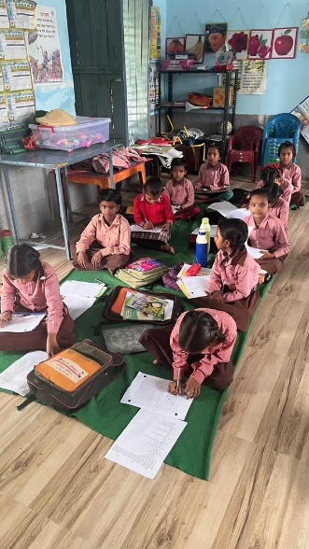 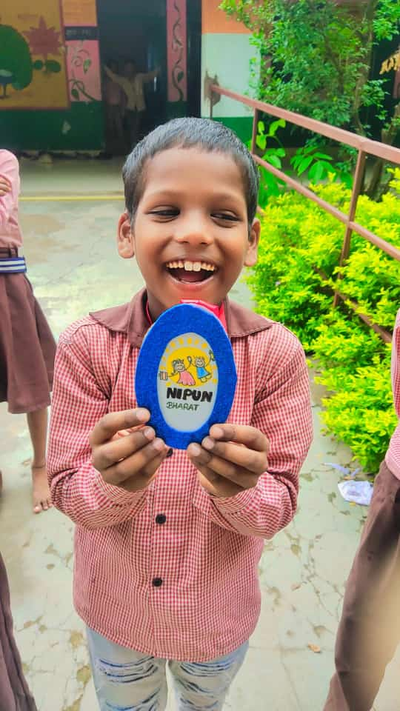 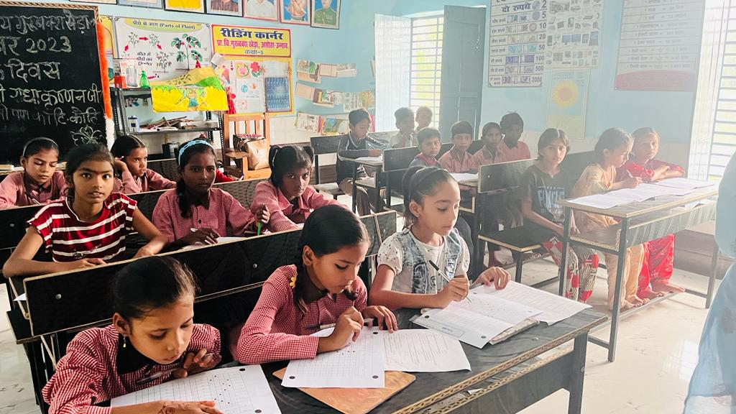

Post results, State analyzes received data on attendance, student learning outcomes, similarity in answers etc. From analyzes state found out schools with abnormally low or high attendance, cheating analysis was done to identify classes, schools, blocks where cheating was supported by teachers or other state actors. Show cause notices and warnings were sent to such schools ensuring accountability and improvement.

Furthermore, high-performing schools received appreciation letters following the result announcement, providing positive reinforcement. Post-result follow-ups with various system actors was also done, which will help state take targeted interventions towards improving learning outcomes.

This successful endeavor reflects the state's dedication to improving the education system and providing a seamless and enhanced experience for teachers and students alike.

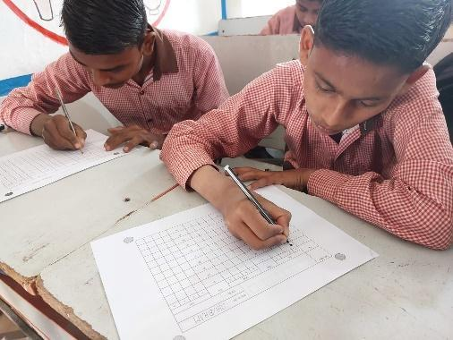 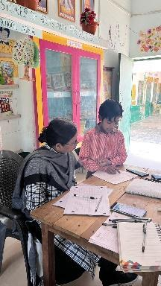 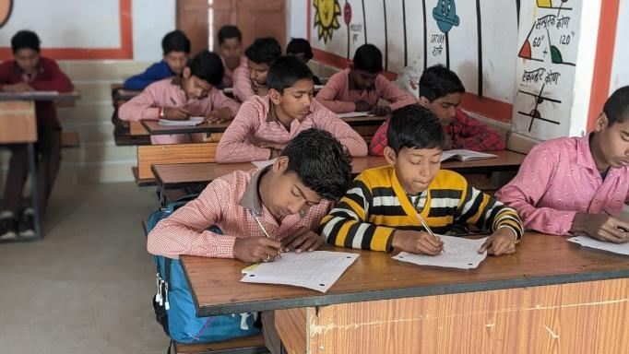

“*We really find filling answer sheets by marking circles exciting, it is very fun to give exams this way”* – With teachers, students also cherished the process of giving assessments in this manner.

**Impact**

This simple, yet powerful, solution has had a significant impact on the education system in Uttar Pradesh. From taking around 120 days for collecting data, Saral Assessments have reduced it to just one day. Digital report cards are generated that bring visibility to parents about their child's learning level, and granular data is now available for multiple stakeholders across the hierarchy.

The assessments covered the entire state rather than being based on a sample, making it more reliable in providing an accurate picture of the education system. The structured, digitized data has made analysis of microscopic data of millions of students possible. Uttar Pradesh was able to gain a deeper understanding of student performance through frequent and at scale assessments which helped them make informed decisions towards key programs such as supporting programs like NIPUN Bharat Mission, creation of learning plans for weak students, teaching plans, more granular remediation plans for teachers and targeted teacher trainings.

**Conclusion**

The success highlights the importance of thorough planning, effective training, and dedicated support to ensure the successful implementation of large-scale educational initiatives. Saral Assessments has brought a positive impact on the education system of Uttar Pradesh, by overcoming key challenges in traditional assessment methods and offering an efficient, cost-time-effective way to digitize data in a reliable manner. Also, the detailed information provided by Saral Assessments has empowered decision-makers to make data-driven choices and take prompt action to enhance educational outcomes in the state.